MSSV: Trần Thị Thanh Thảo

Họ và tên: Trần Thị Thanh Thảo

Lớp: DHHTTT18ATT

MySQL Select: Exercise 1

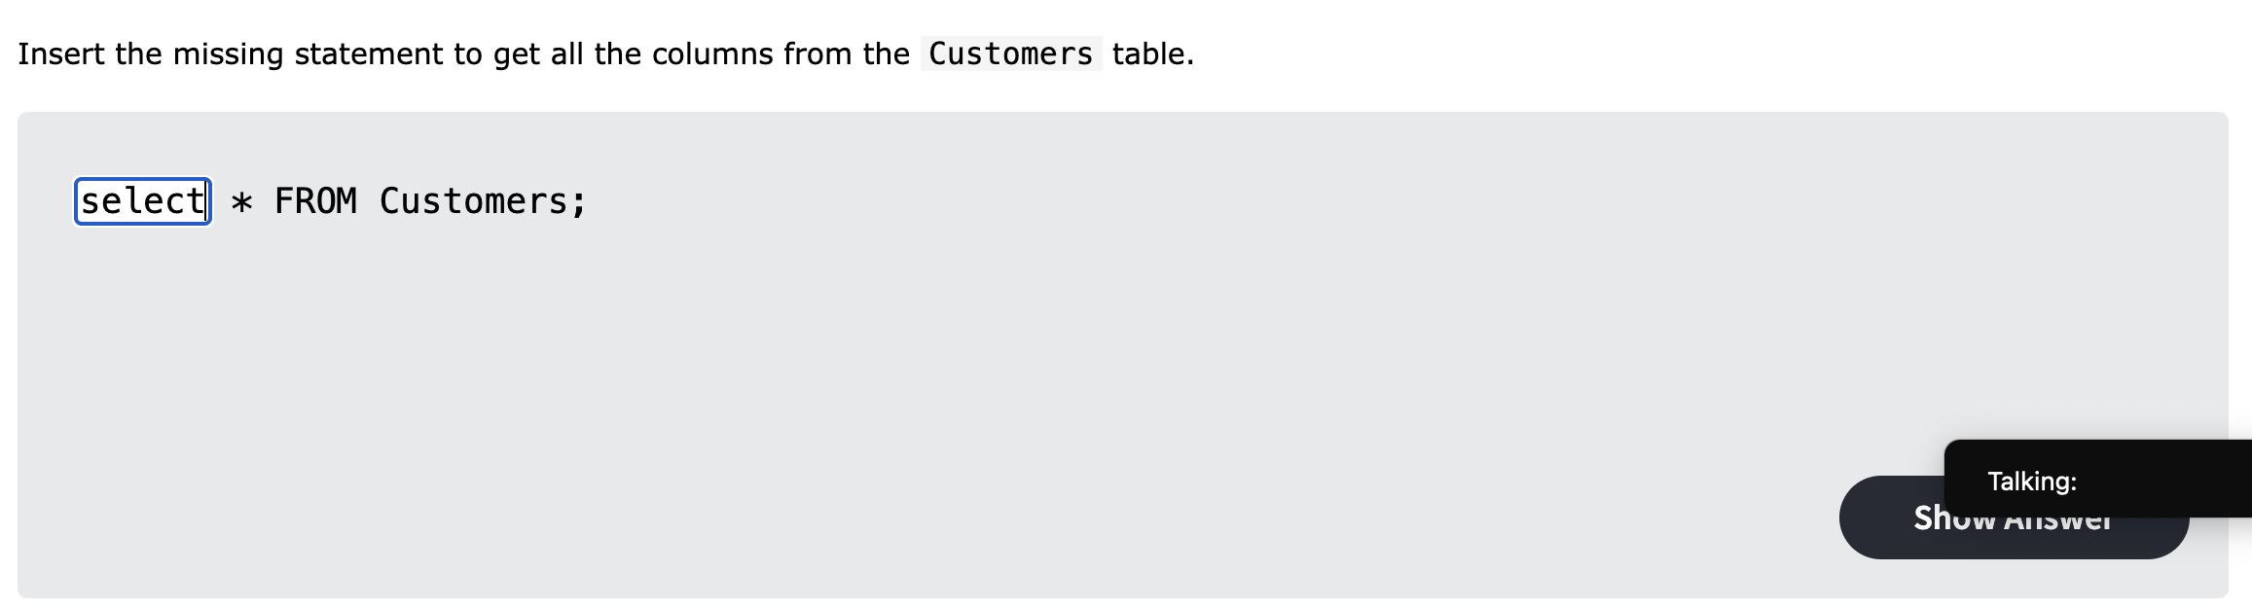

MySQL Select: Exercise 2

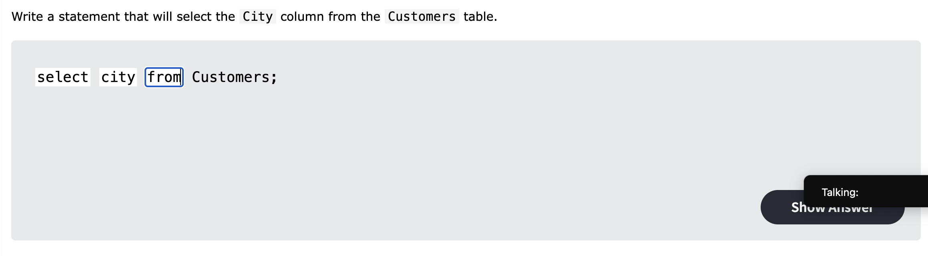

MySQL Select: Exercise 3

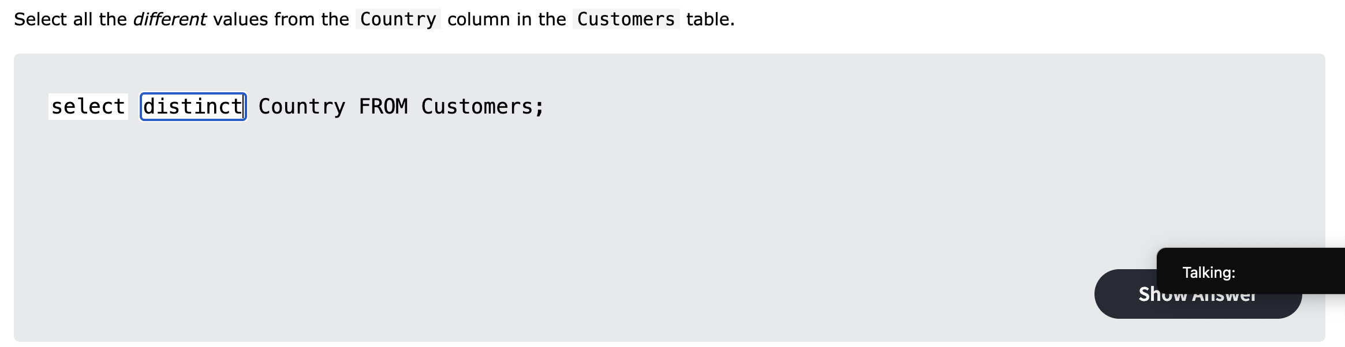

MySQL Where: Exercise 1

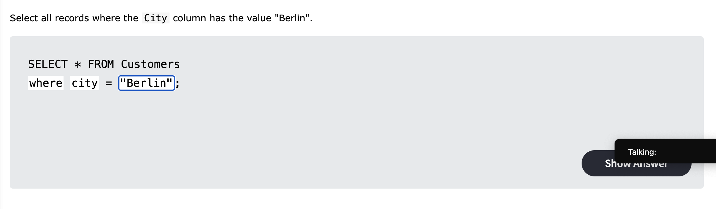

MySQL Where: Exercise 2

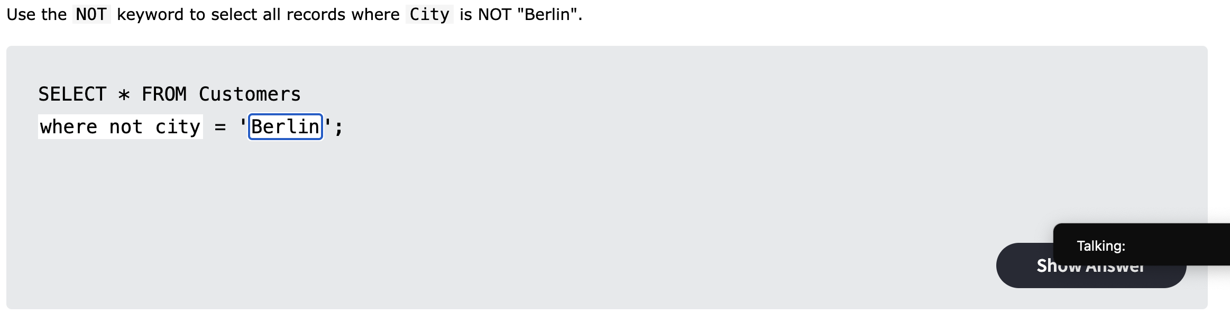

MySQL Where: Exercise 3

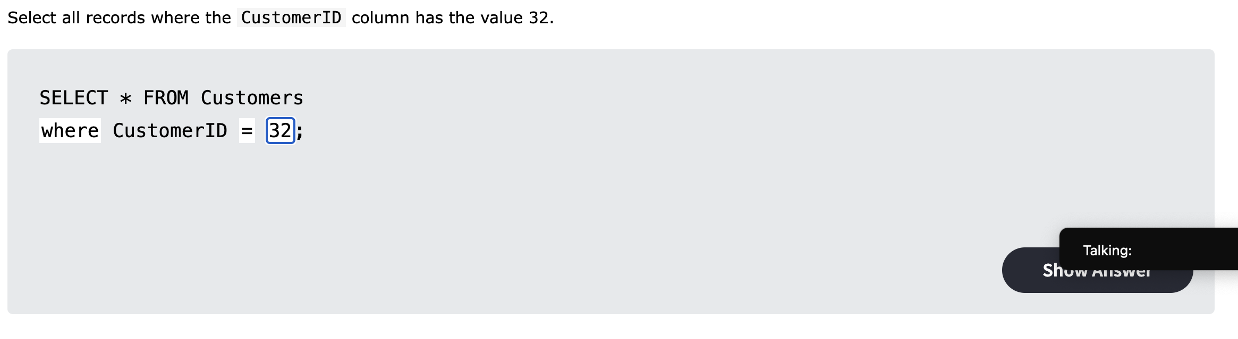

MySQL Where: Exercise 4

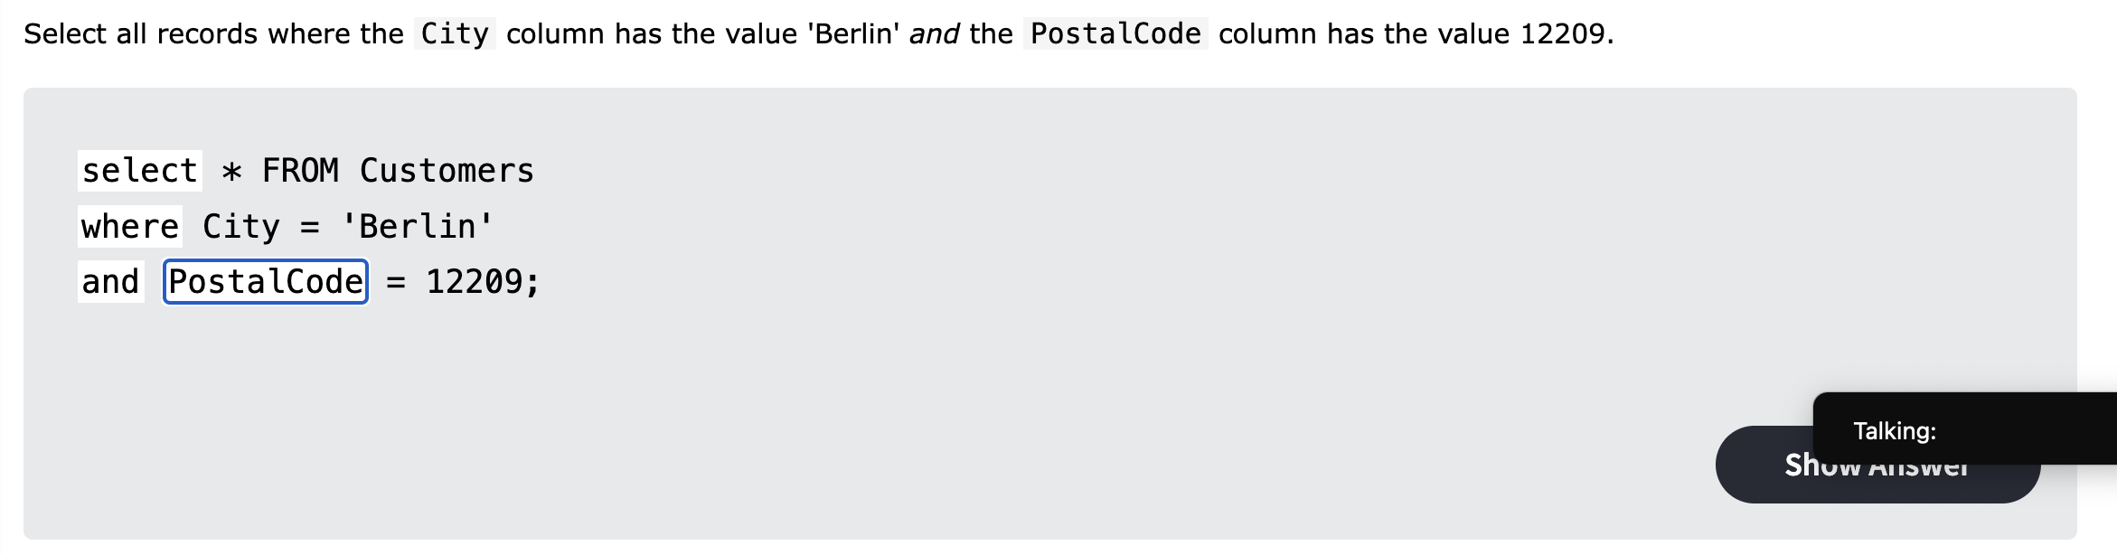

MySQL Where: Exercise 5

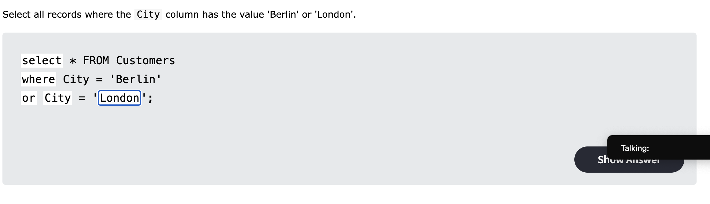

MySQL Order By: Exercise 1

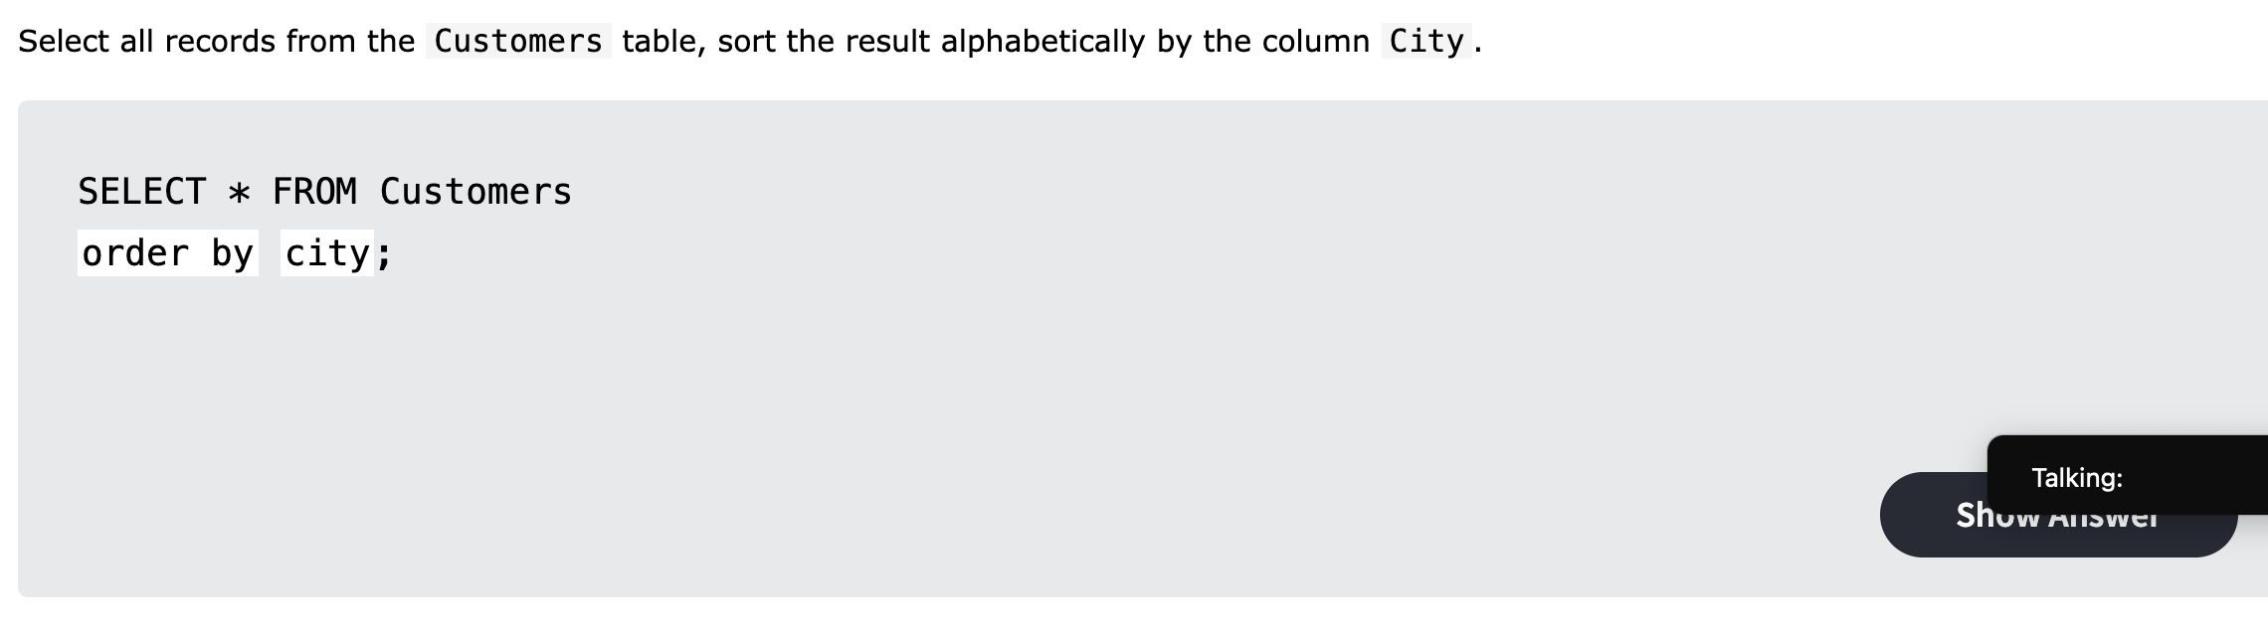

MySQL Order By: Exercise 2

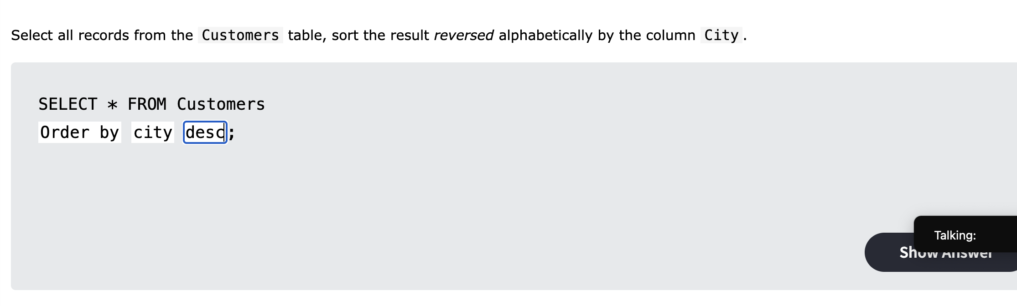

MySQL Order By: Exercise 3

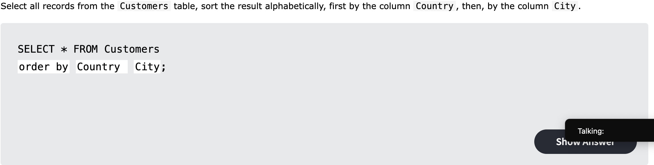

MySQL Insert: Exercise 1

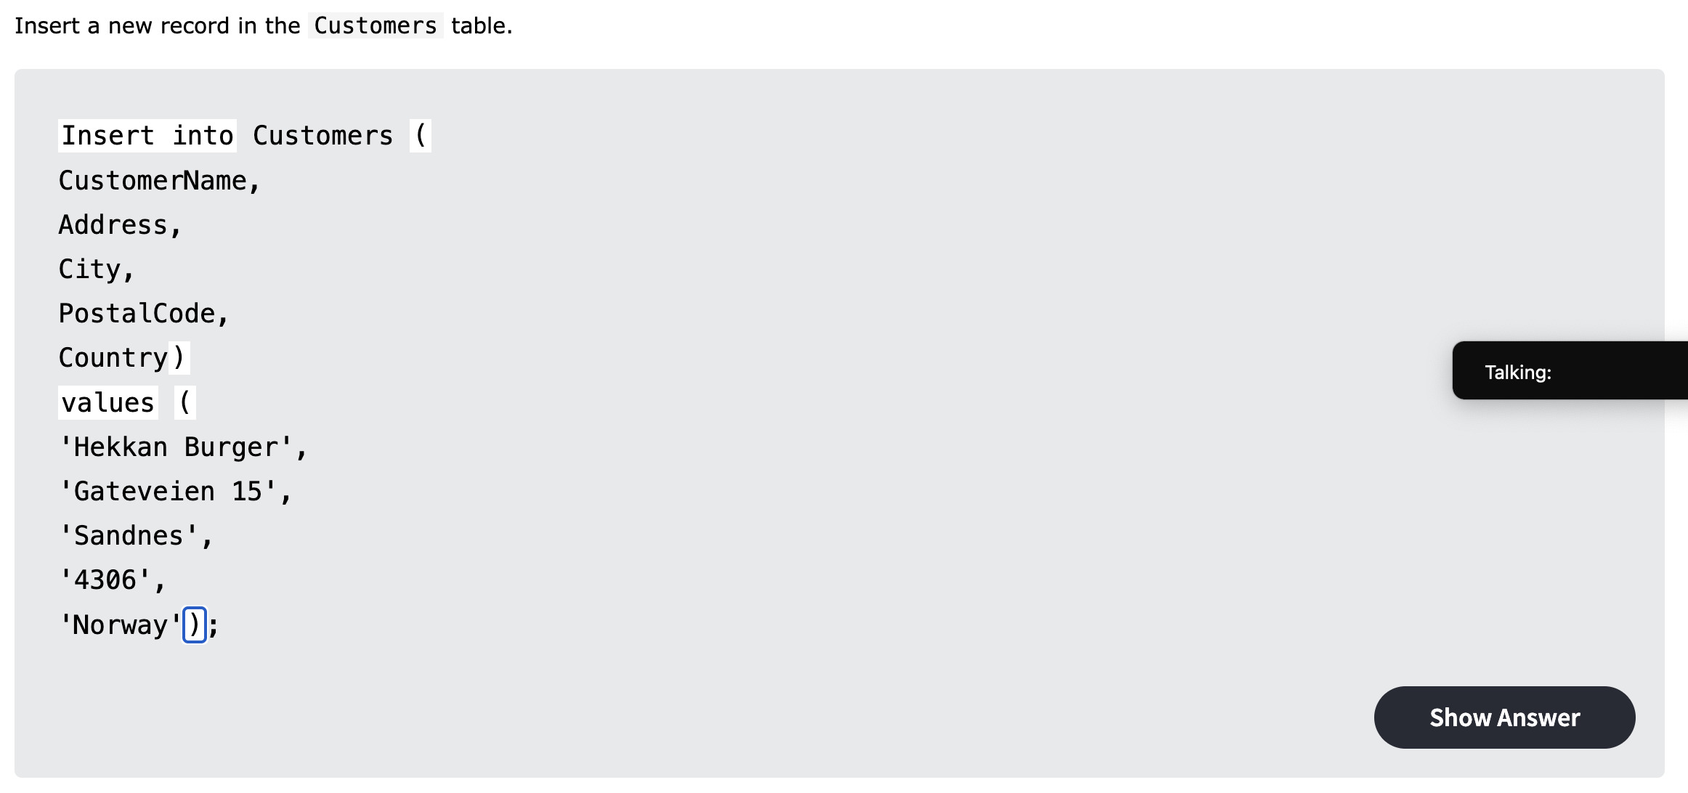

MySQL Null: Exercise 1

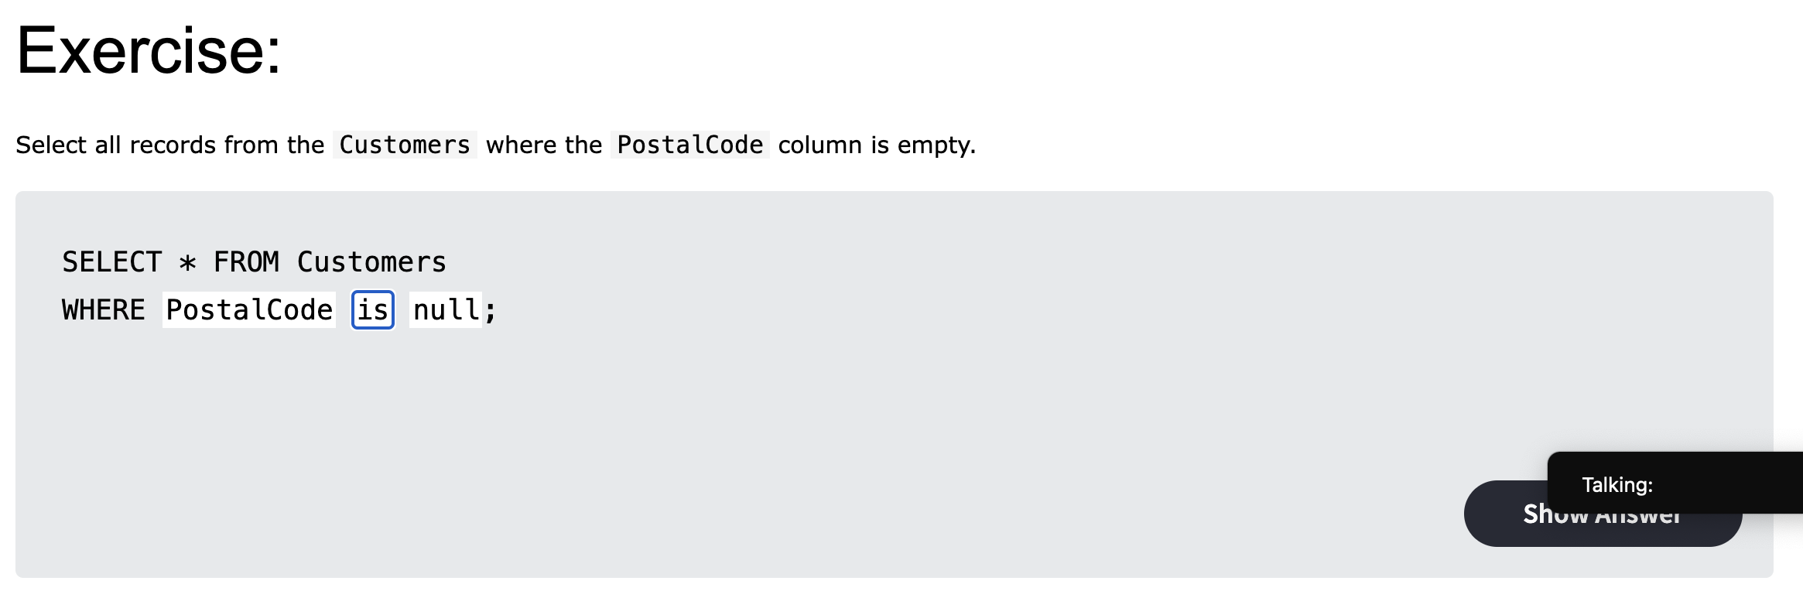

MySQL Null: Exercise 2

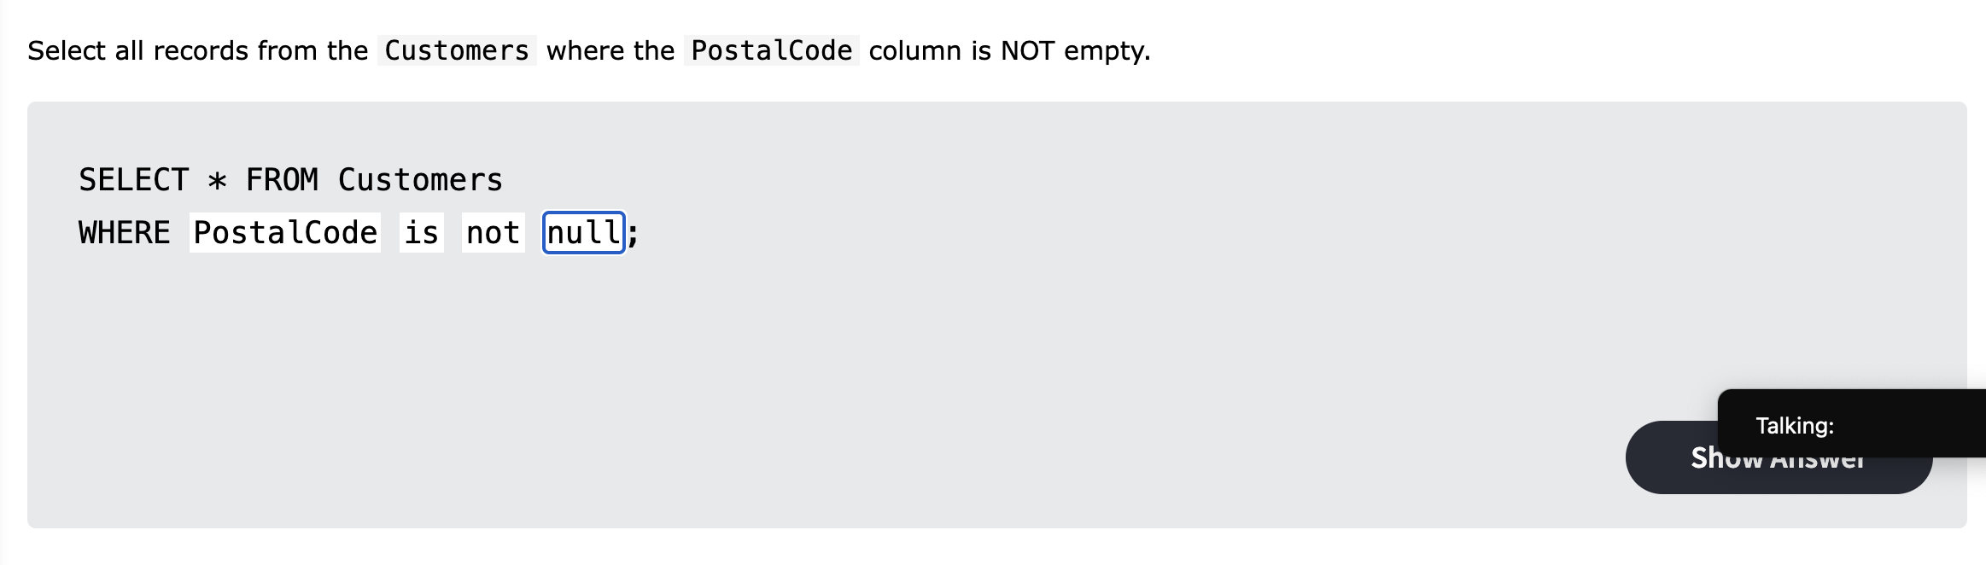

MySQL Update: Exercise 1

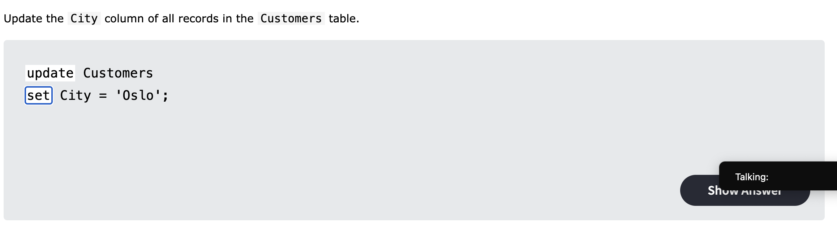

MySQL Update: Exercise 2

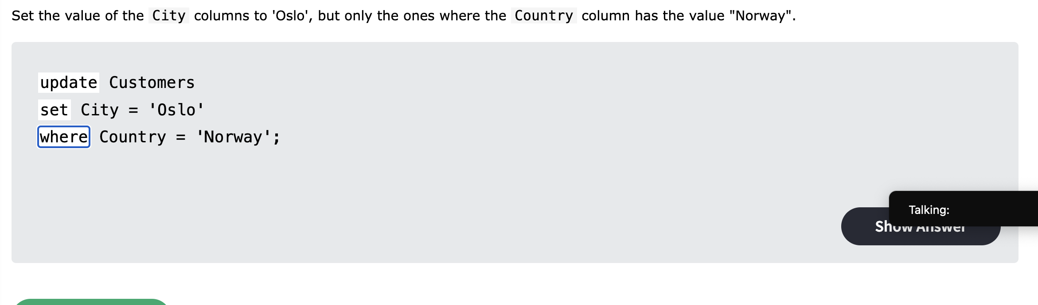

MySQL Update: Exercise 3

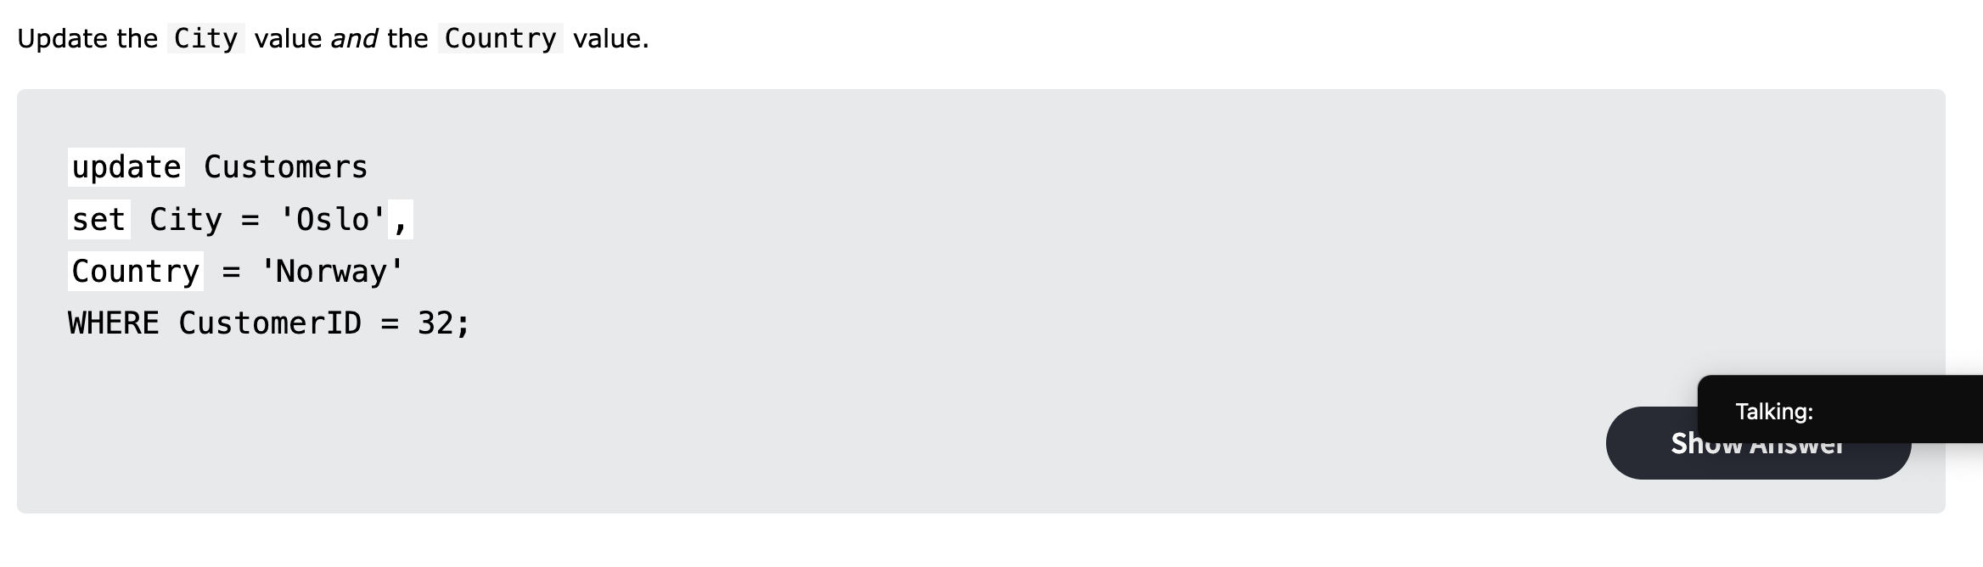

MySQL Delete: Exercise 1

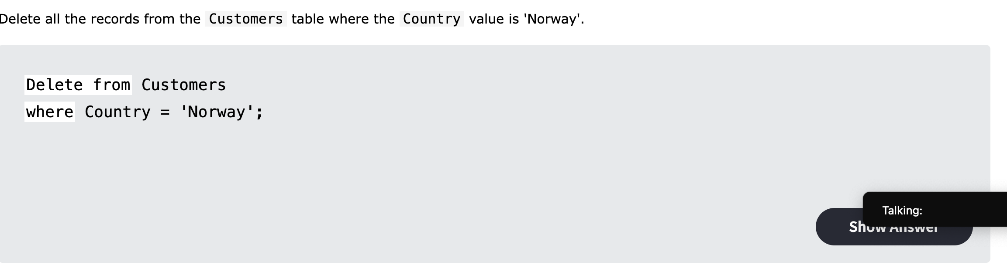

MySQL Delete: Exercise 2

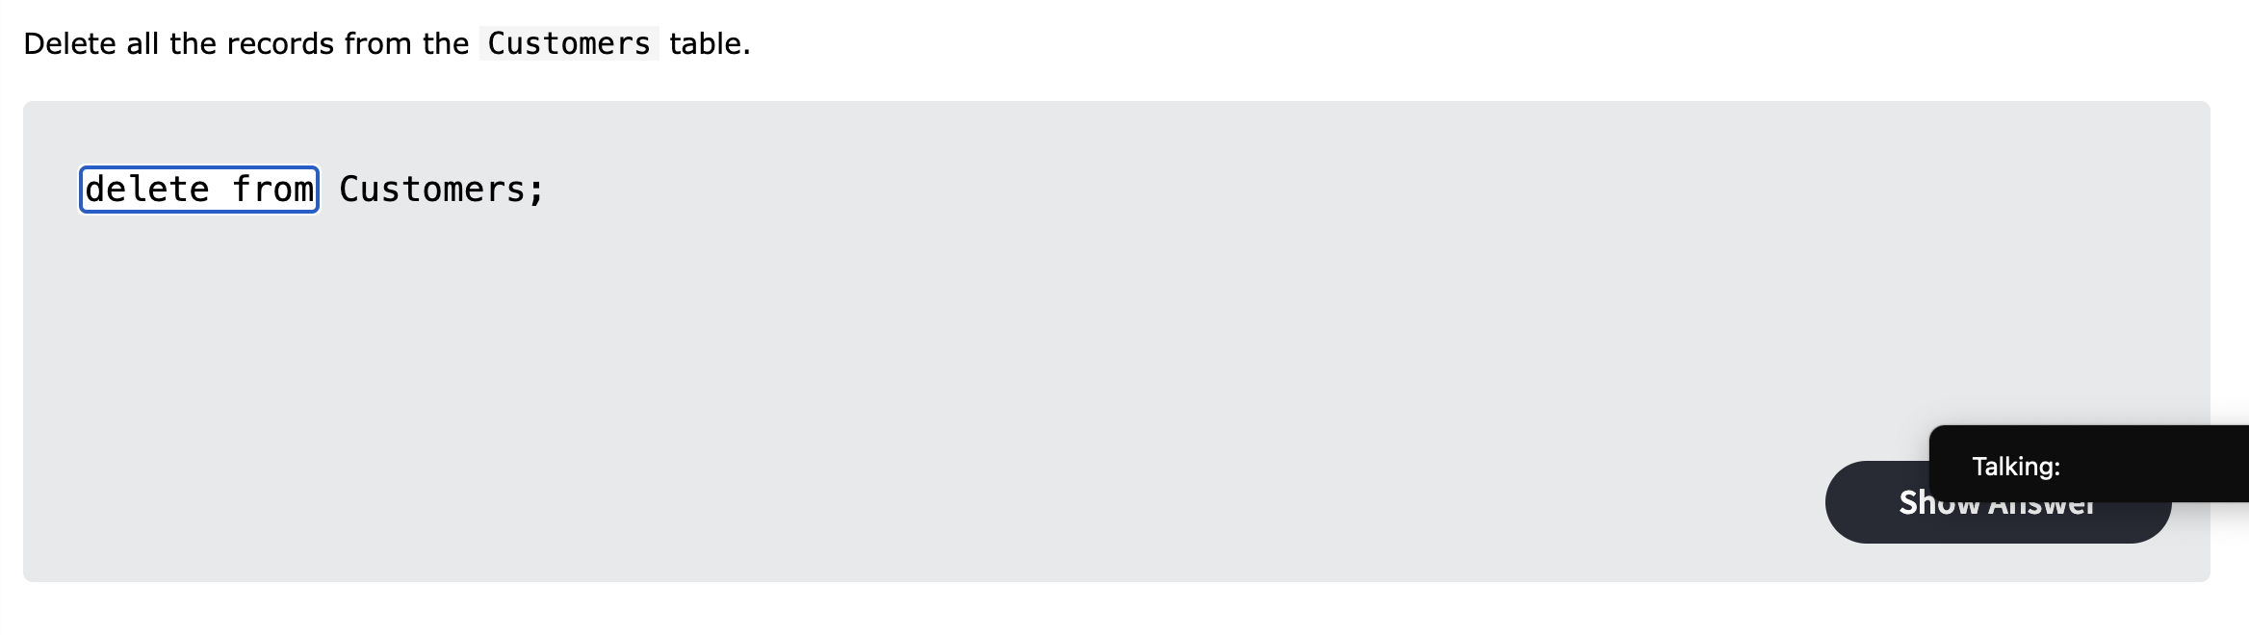

MySQL Functions: Exercise 1

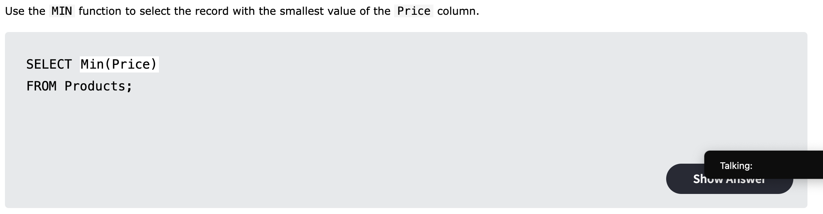

MySQL Functions: Exercise 2

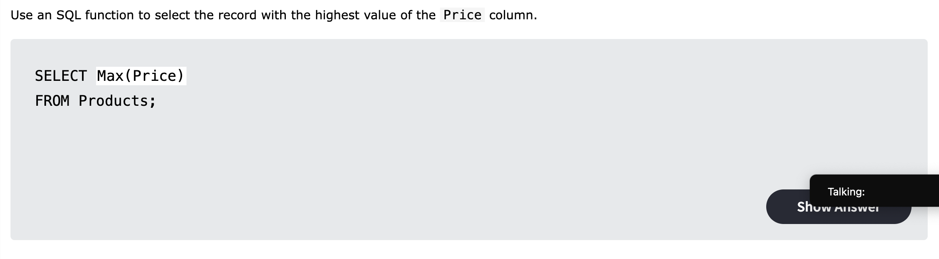

MySQL Functions: Exercise 3

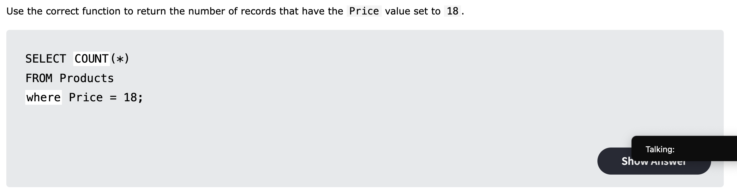

MySQL Functions: Exercise 4

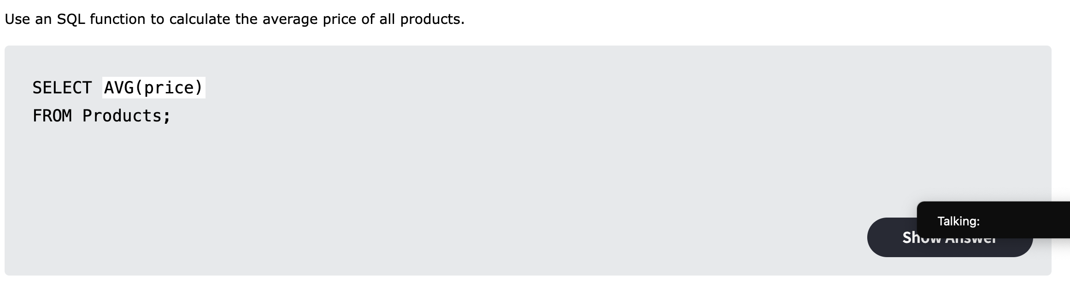

MySQL Functions: Exercise 5

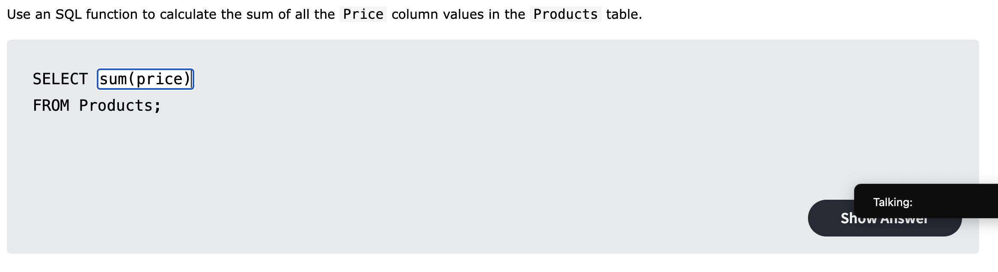

MySQL Like: Exercise 1

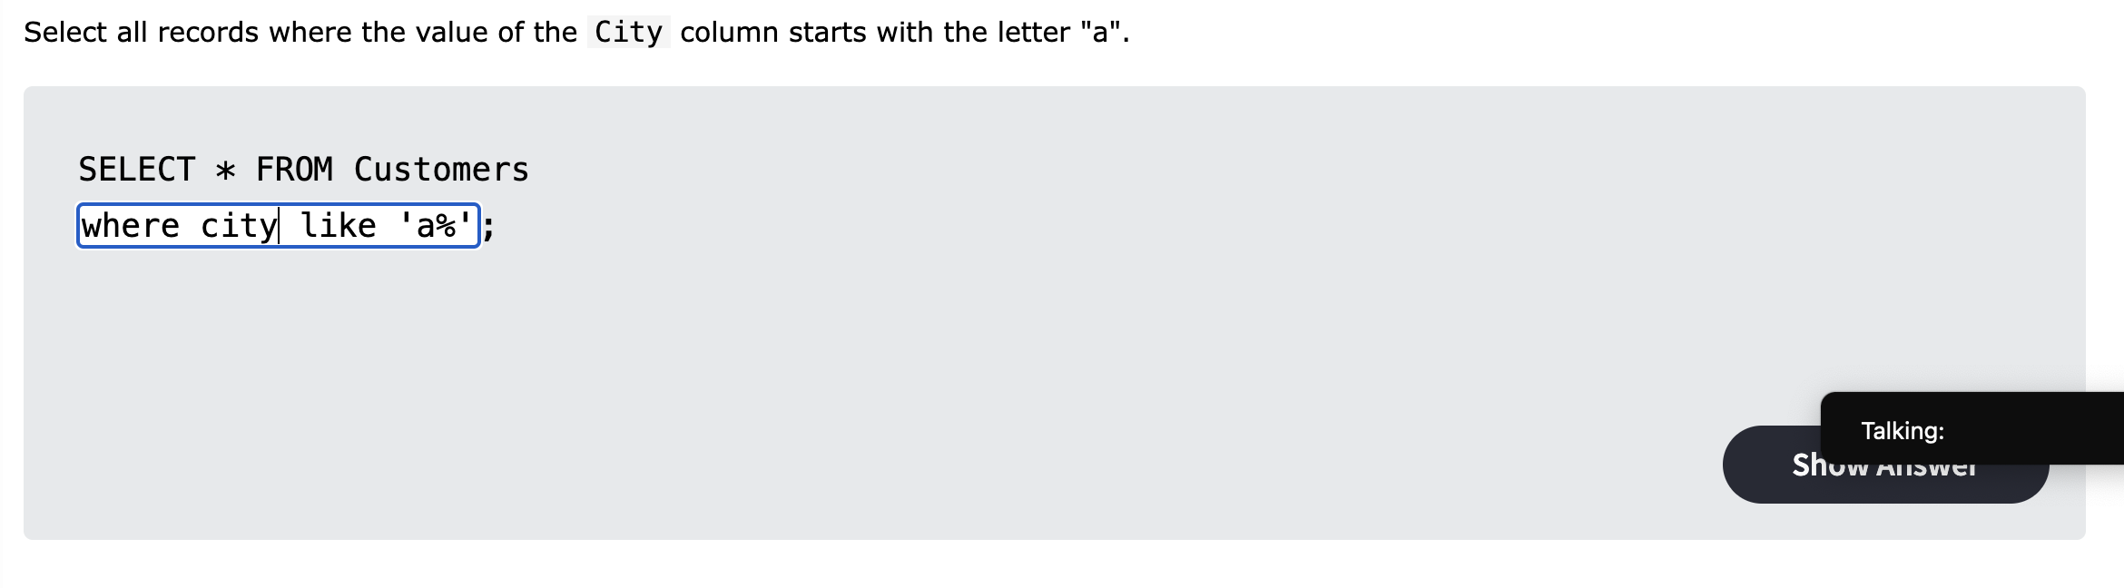

MySQL Like: Exercise 2

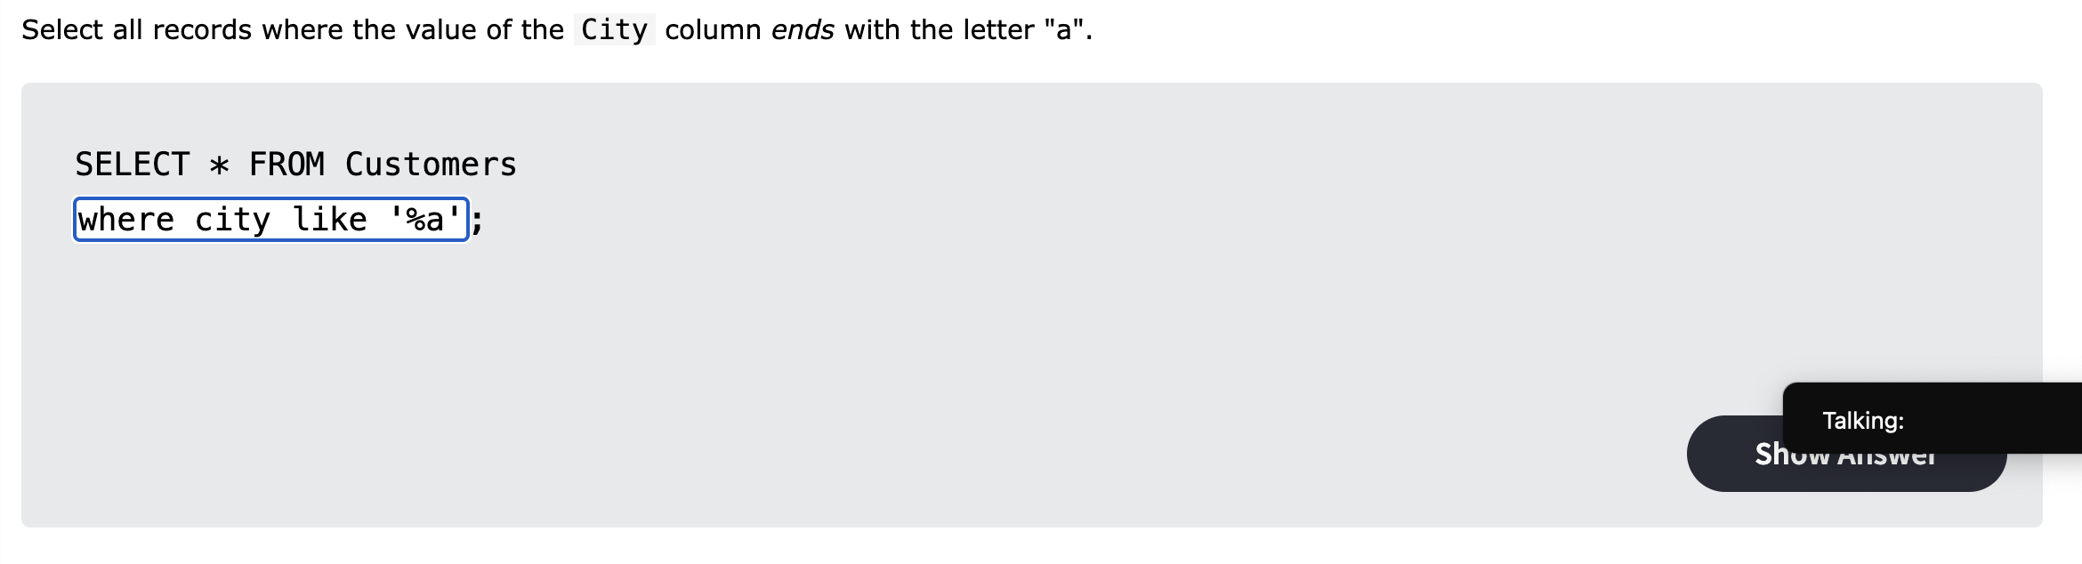

MySQL Like: Exercise 3

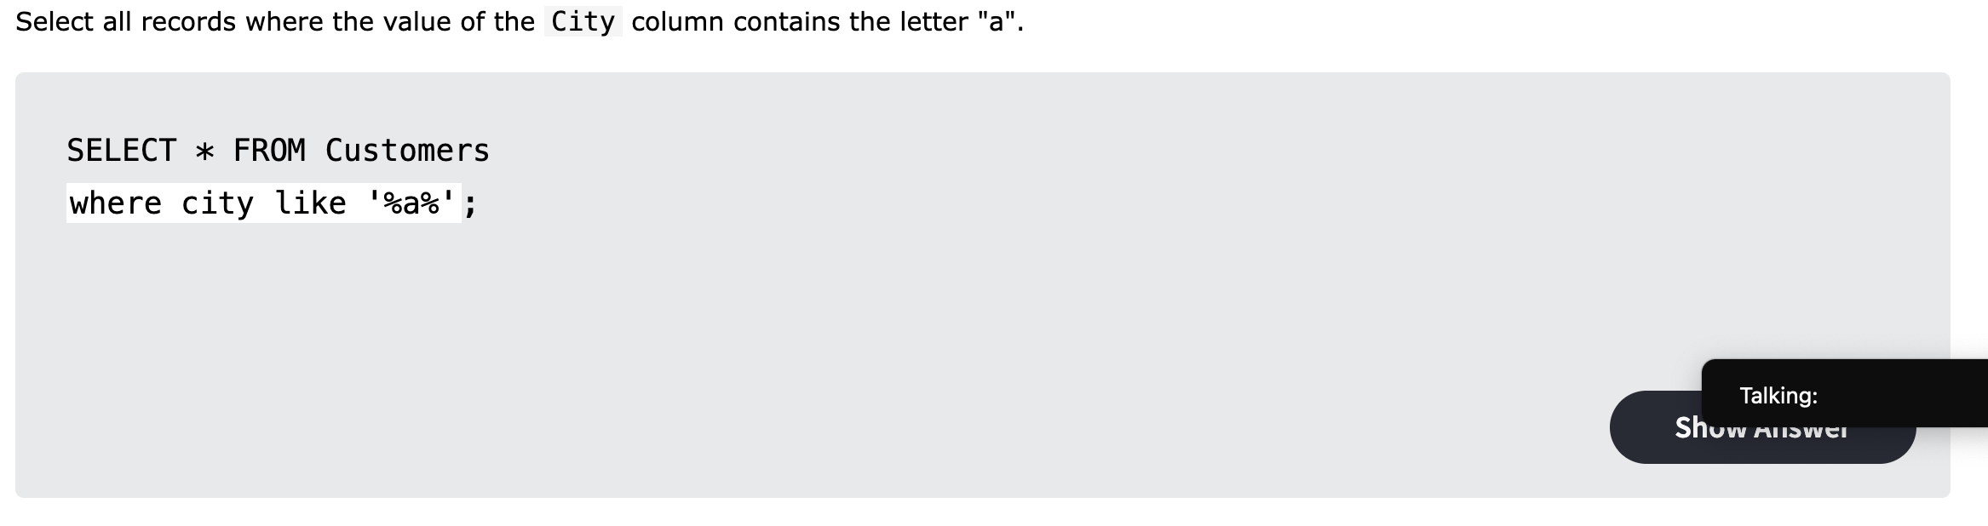

MySQL Like: Exercise 4

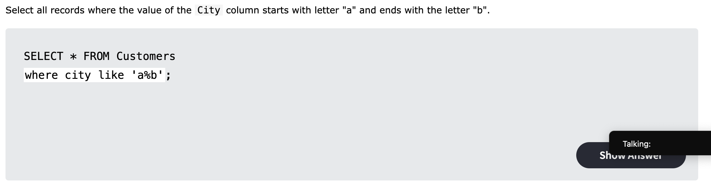

MySQL Like: Exercise 5

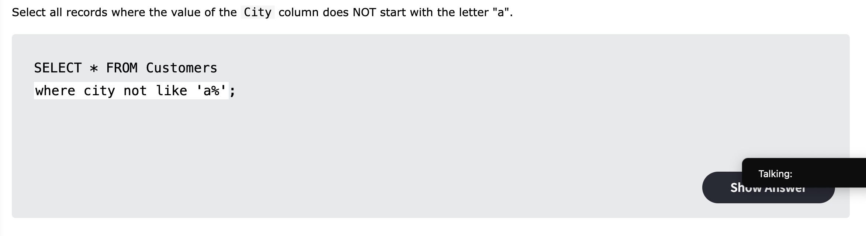

MySQL Wildcards: Exercise 1

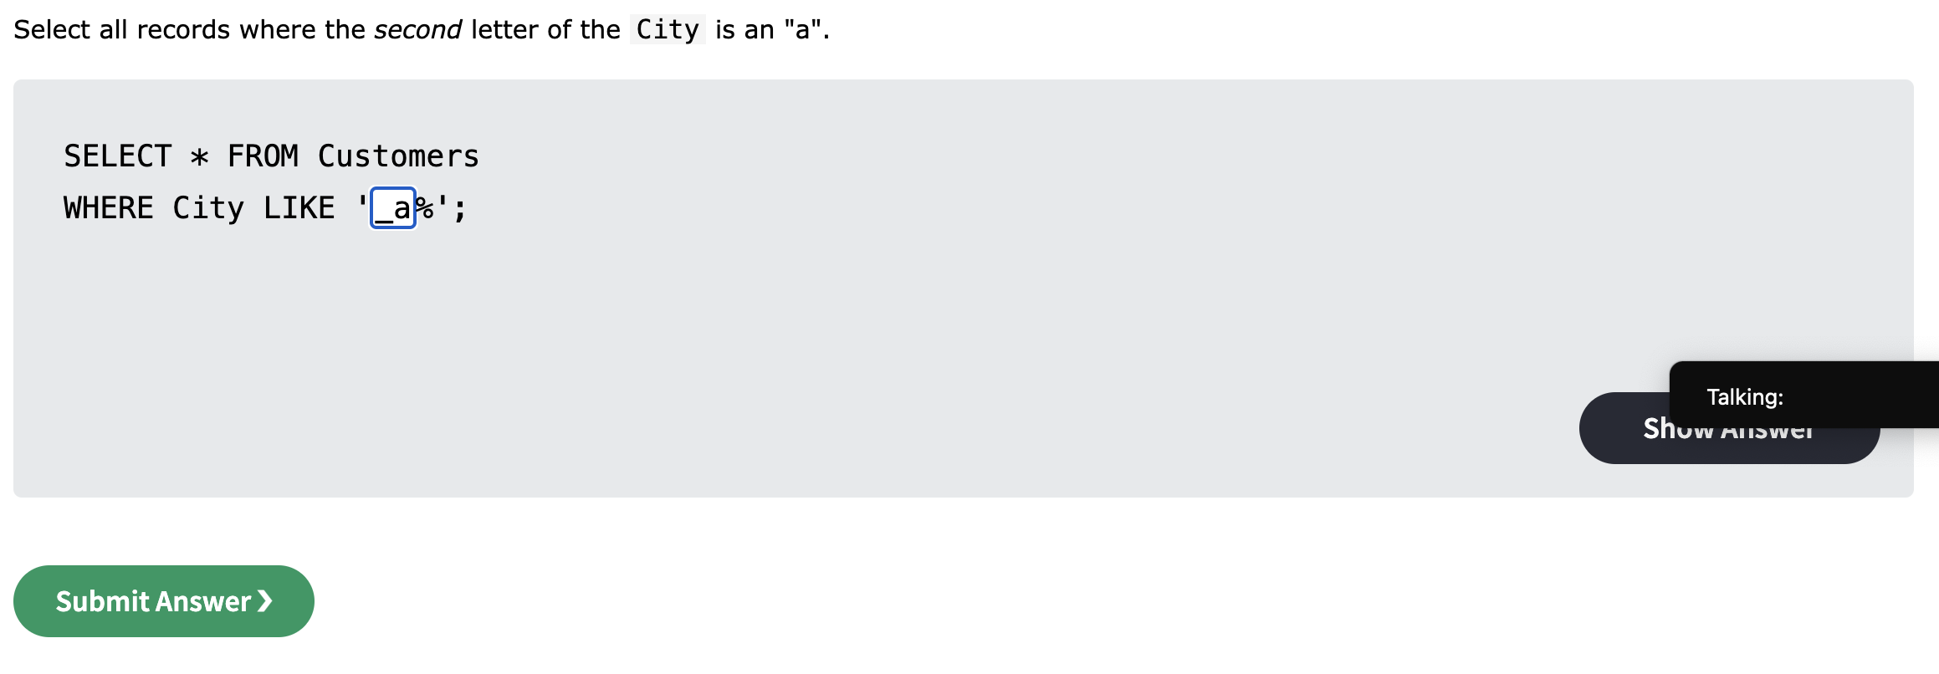

MySQL Wildcards: Exercise 2

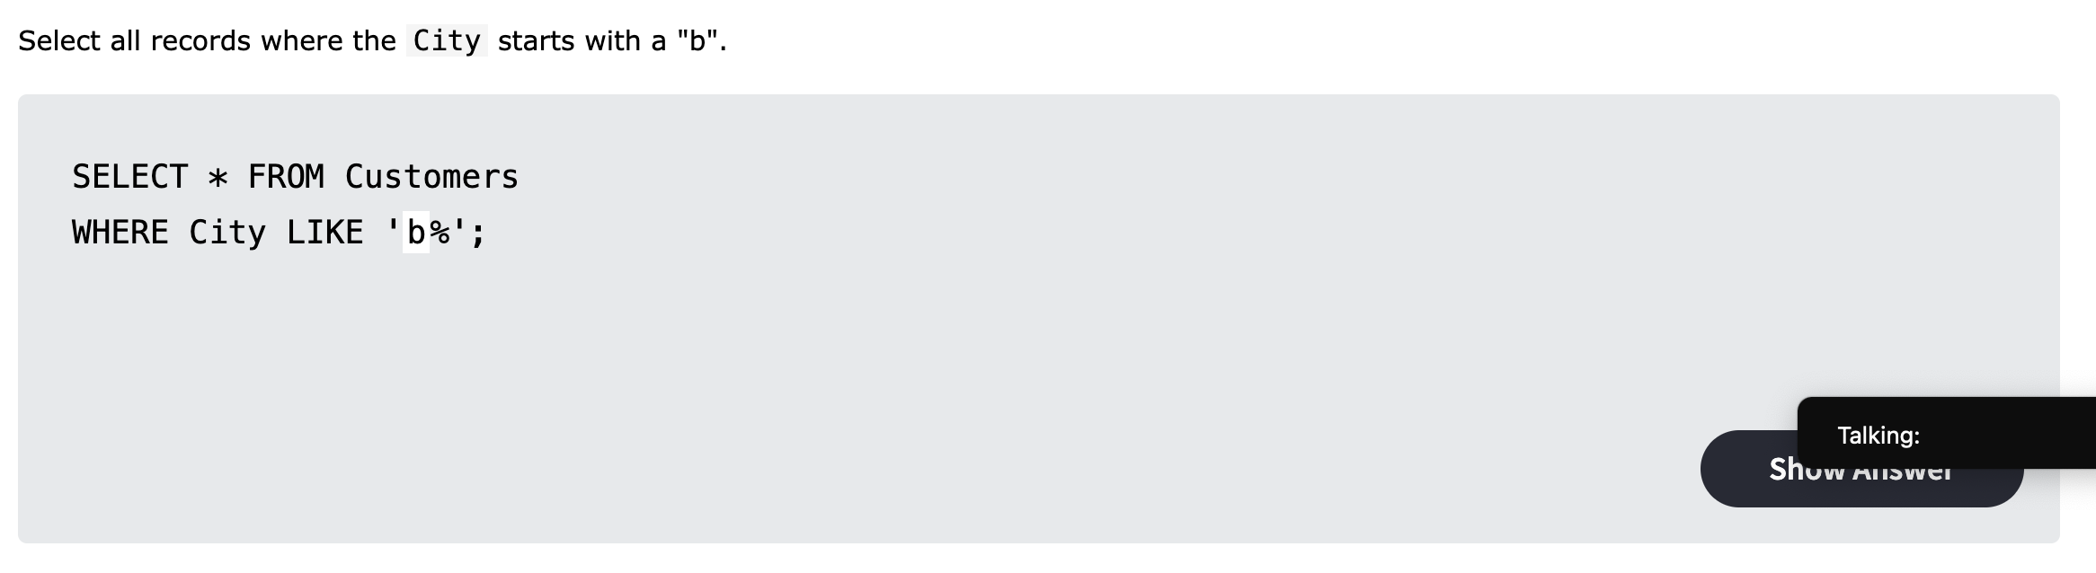

MySQL In: Exercise 1 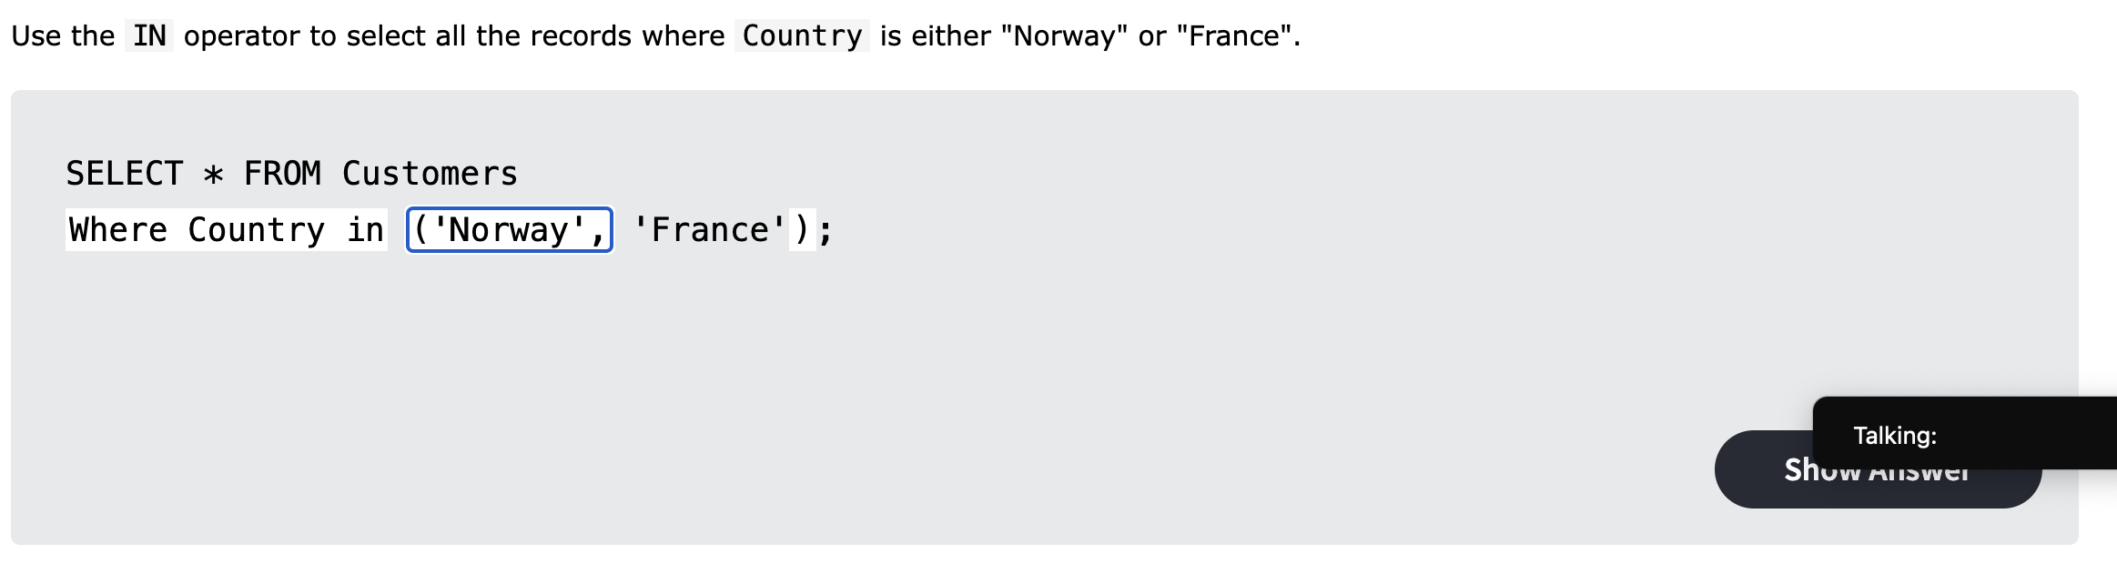

MySQL In: Exercise 2

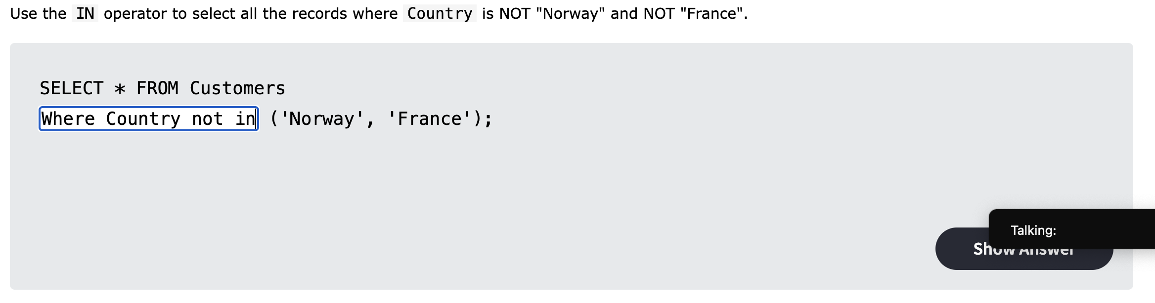

MySQL Between: Exercise 1

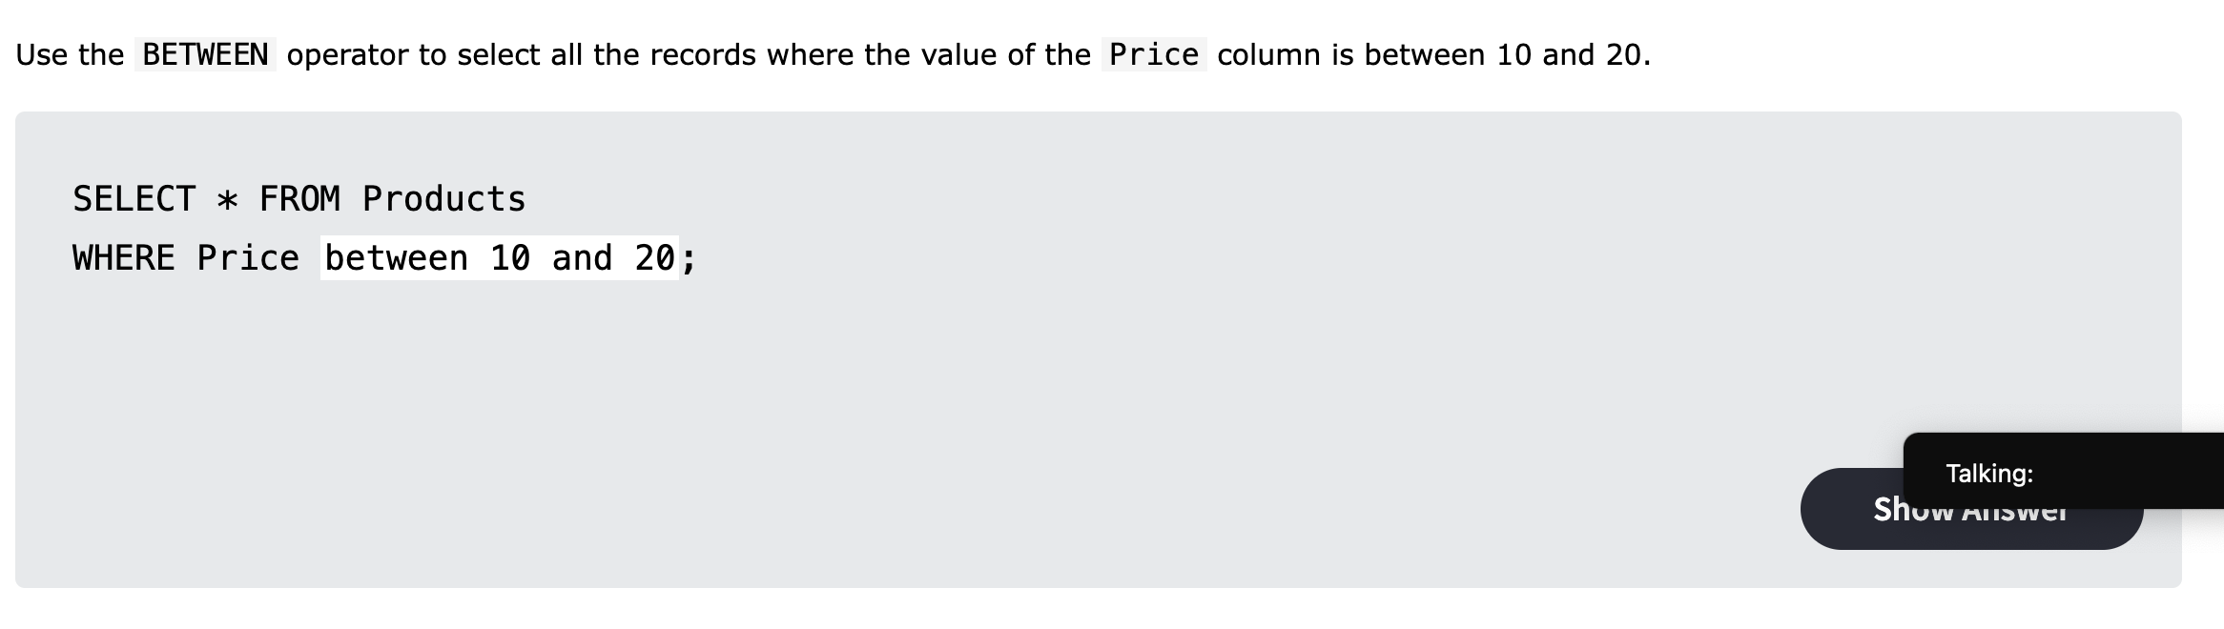

MySQL Between: Exercise 2

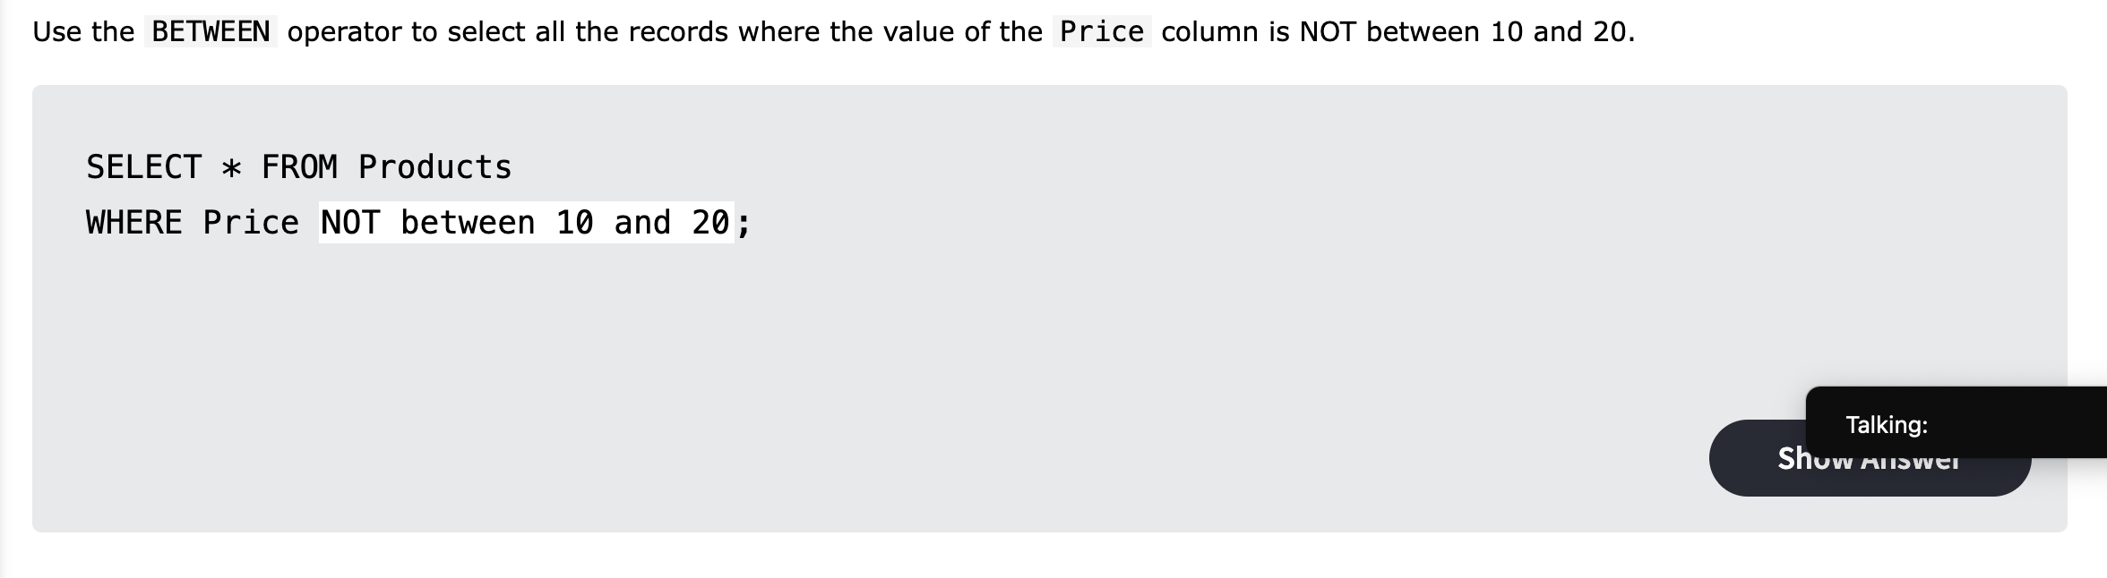

MySQL Between: Exercise 3

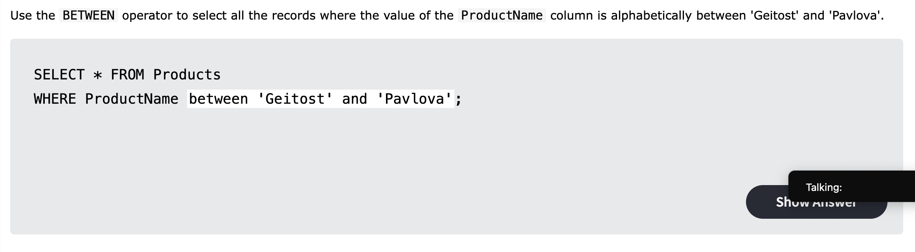

MySQL Alias: Exercise 1

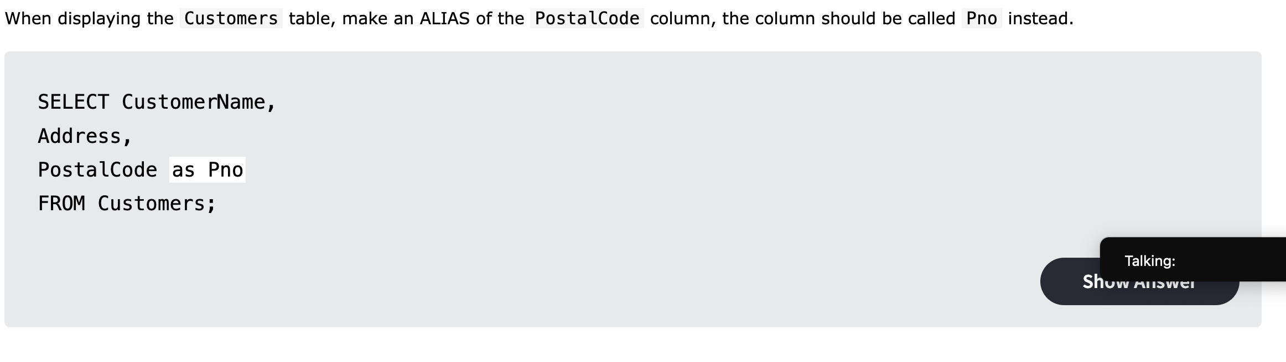

MySQL Alias: Exercise 2

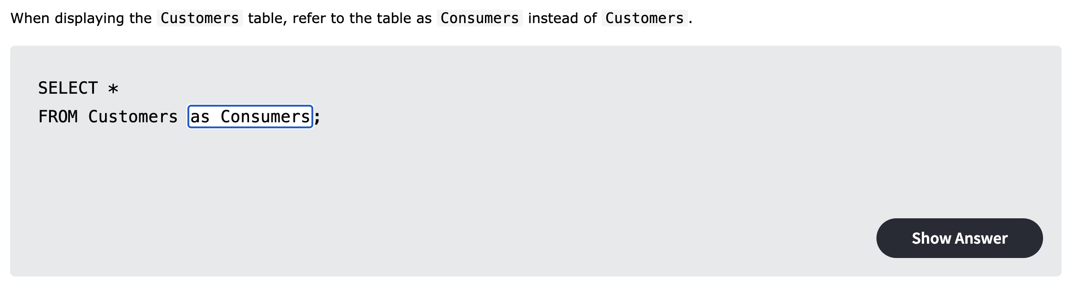

MySQL Join: Exercise 1

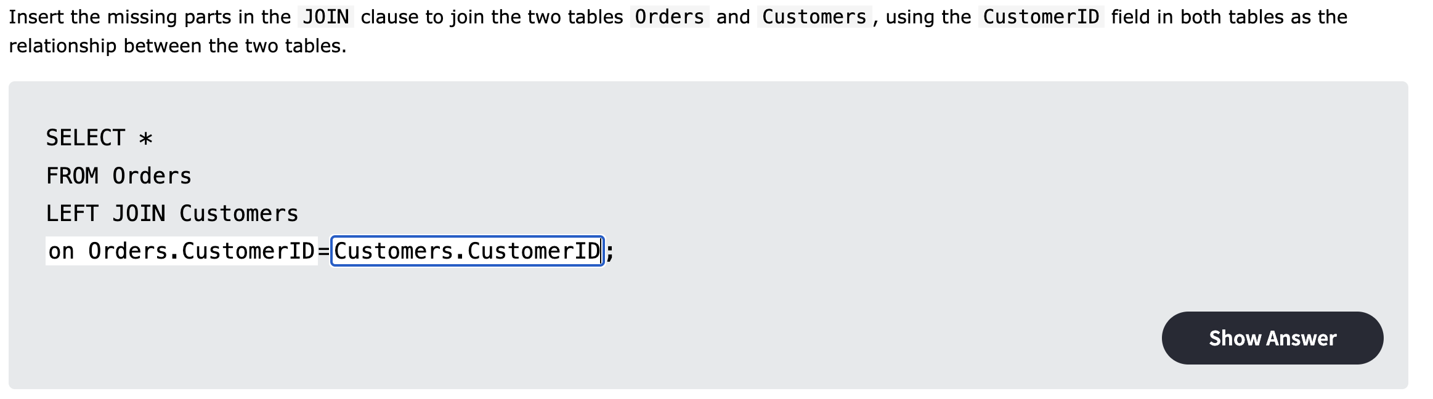

MySQL Join: Exercise 2

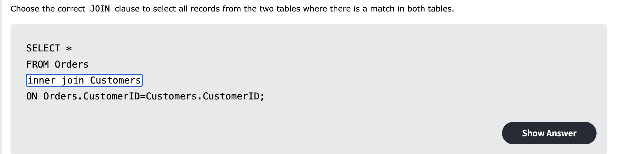

MySQL Join: Exercise 3

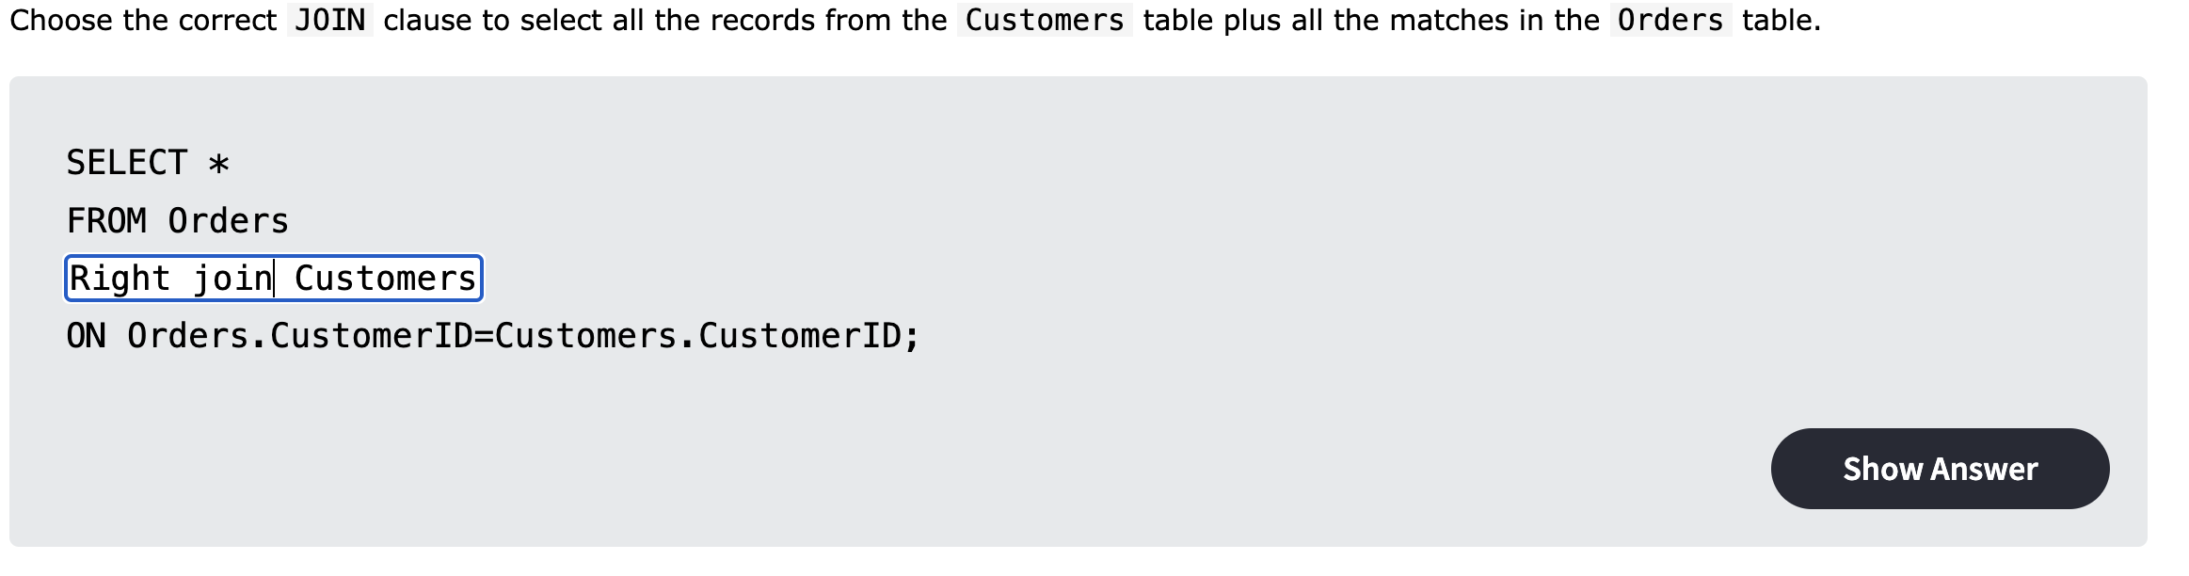

MySQL Group By: Exercise 1

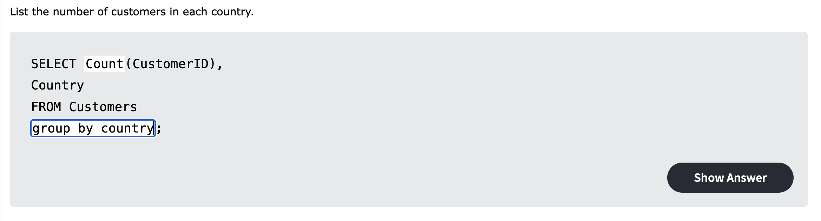

MySQL Group By: Exercise 2

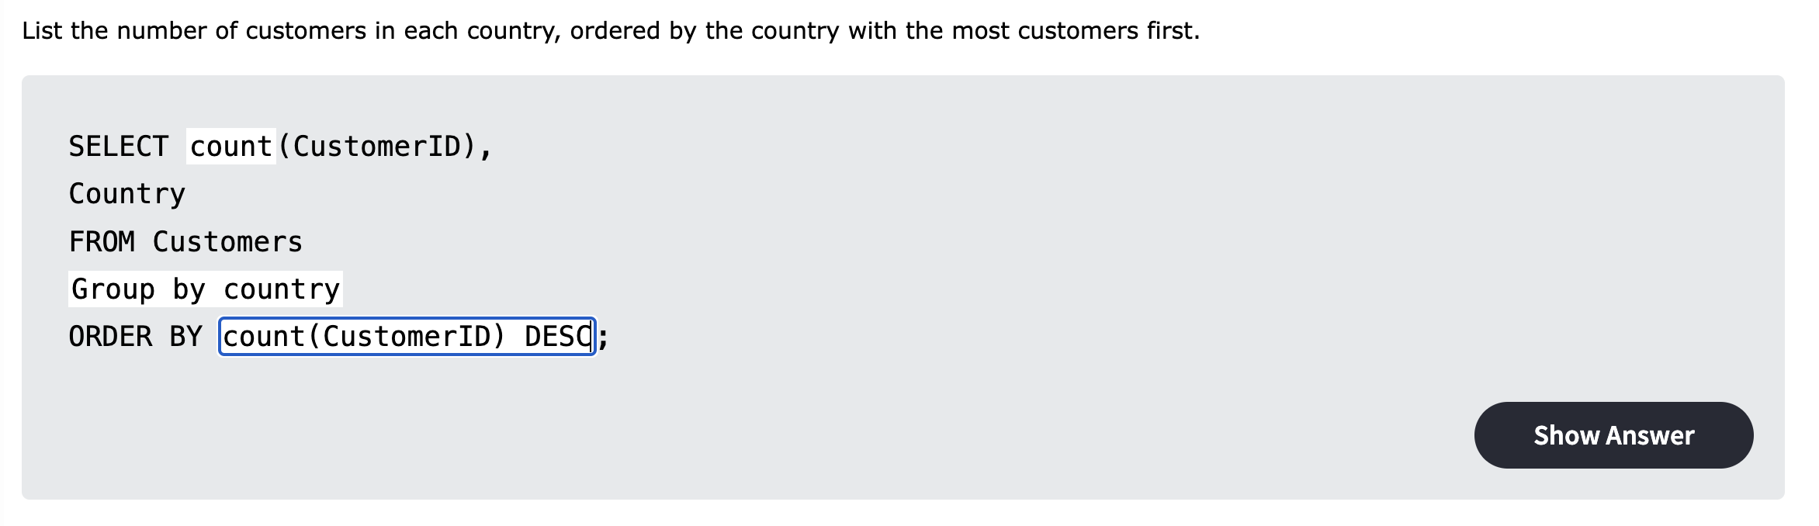

MySQL Database: Exercise 1

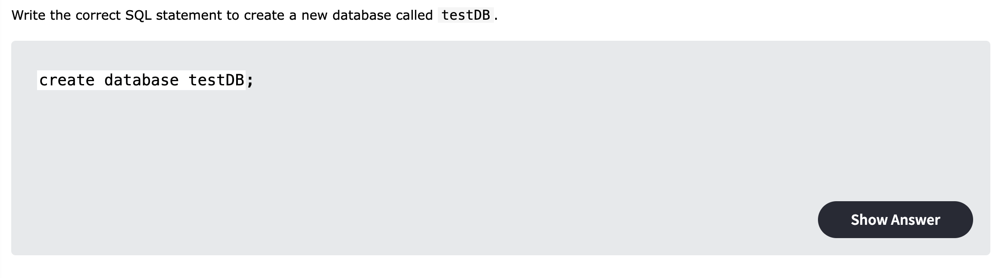

MySQL Database: Exercise 2

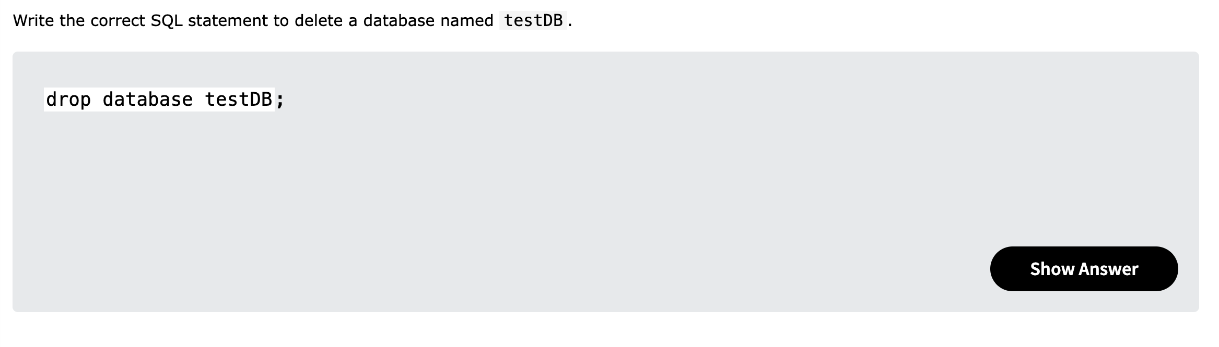

MySQL Database: Exercise 3

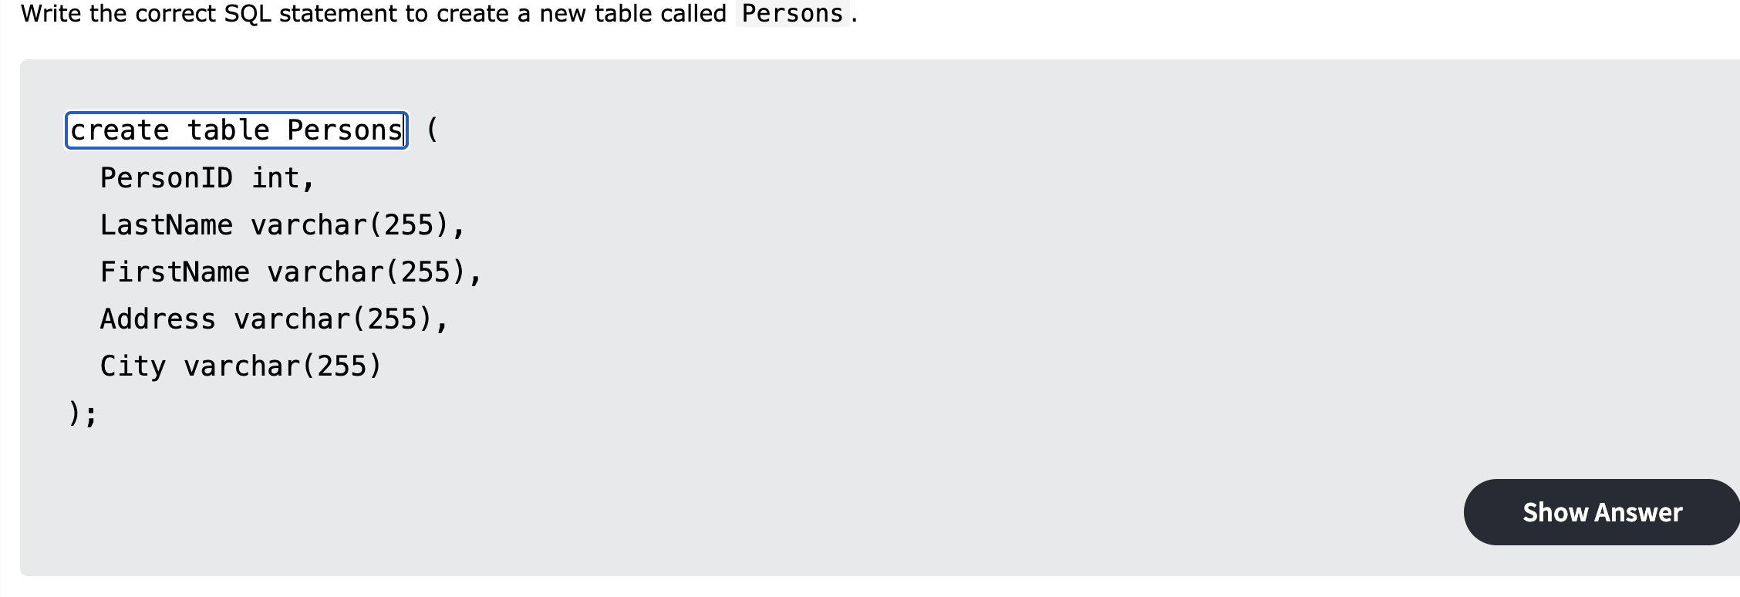

MySQL Database: Exercise 4

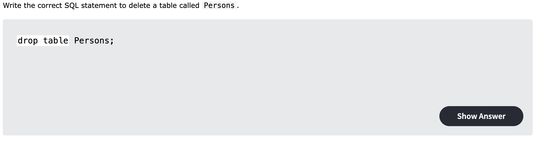

MySQL Database: Exercise 5

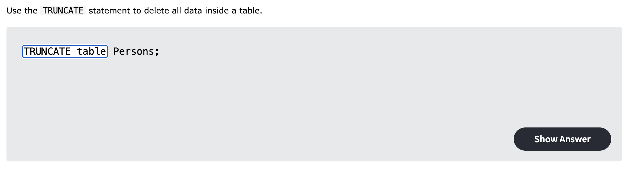

MySQL Database: Exercise 6

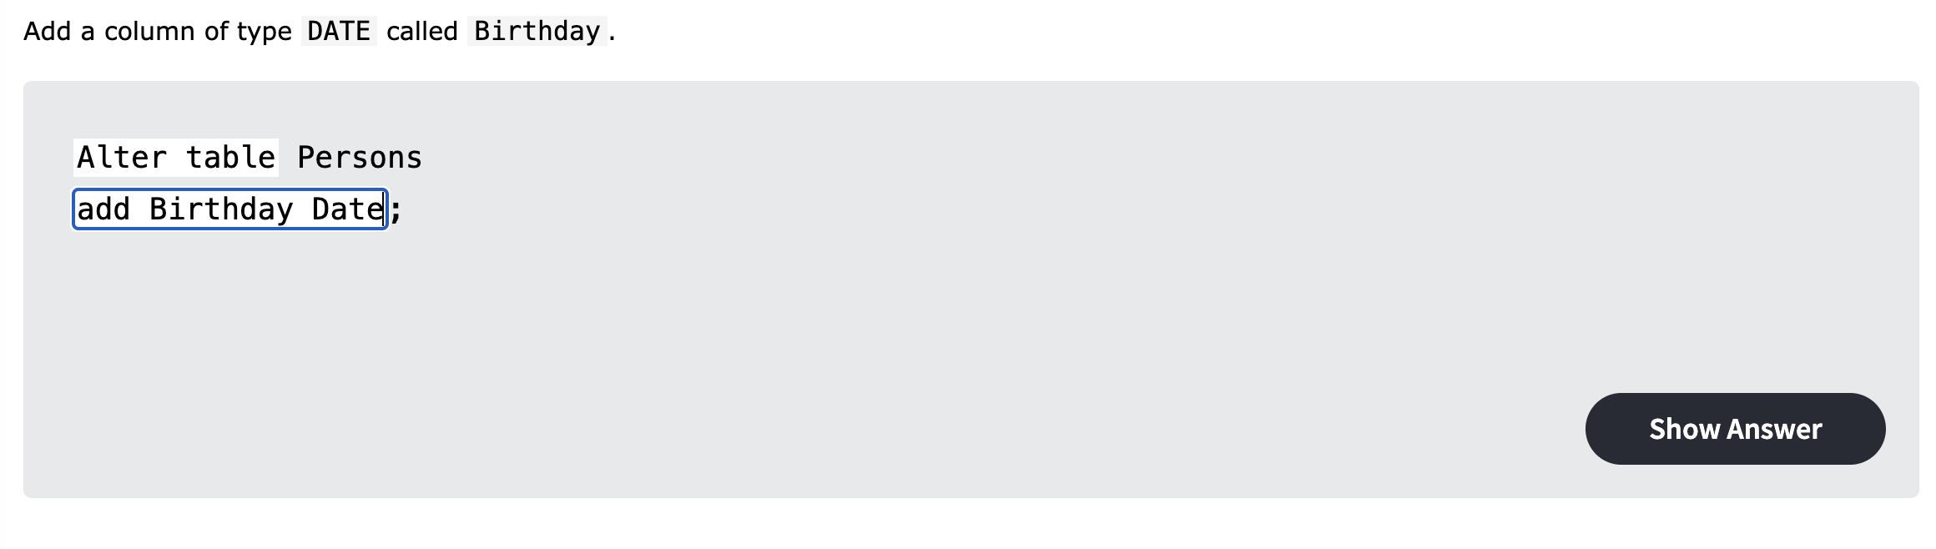

MySQL Database: Exercise 7

